Soueich
55,6
350m
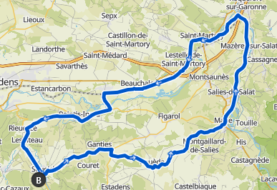  Mane-Roquefort-Piste cyclable-St-Martory-Lestelle-Beauchalot-Labarthe-Inard-Pointis-Inard-Lespiteau-Soueich-Ganties-Rouede- | 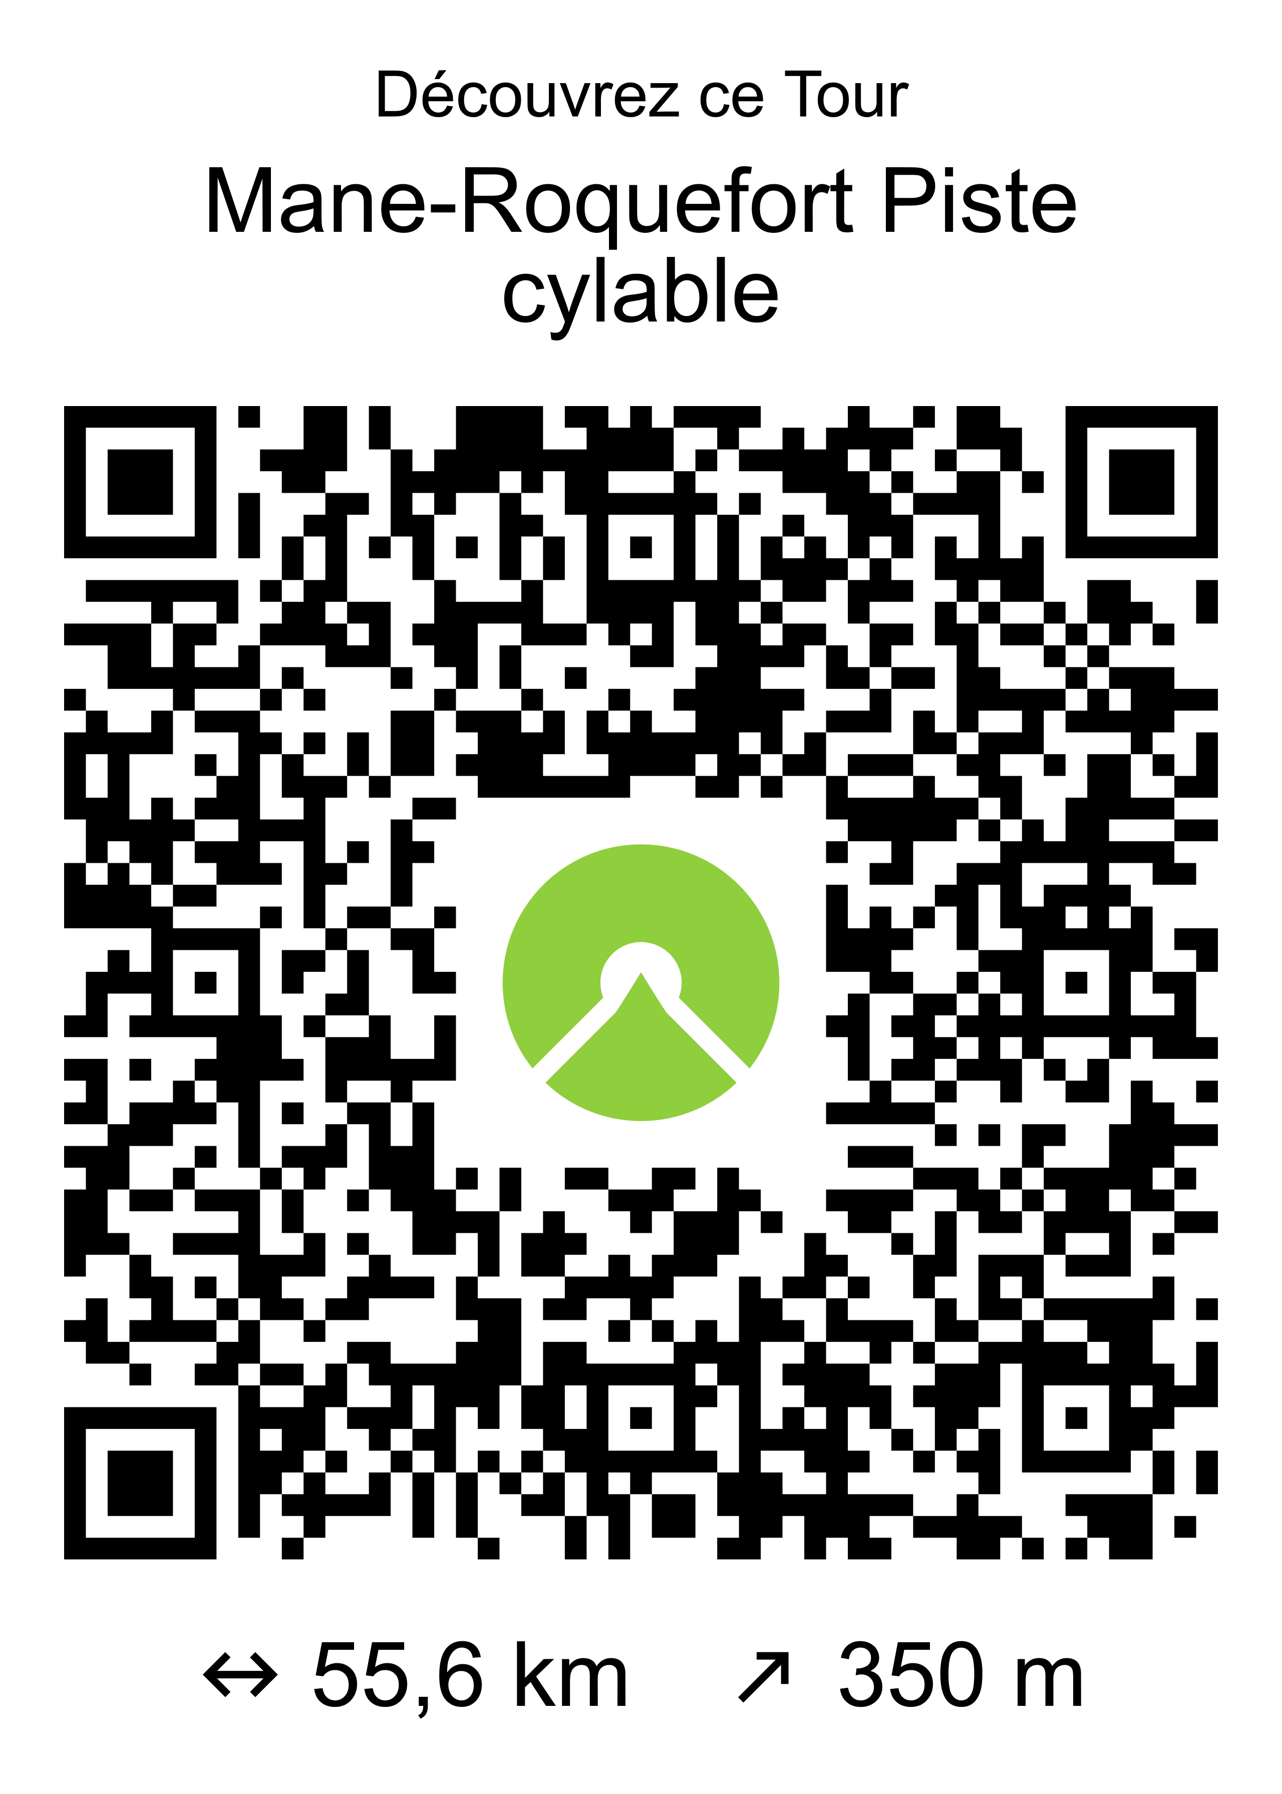 | Mane-Roquefort-Piste cyclable-St-Martory-Lestelle-Beauchalot-Labarthe-Inard-Pointis-Inard-Lespiteau-Soueich-Ganties-Rouede-
  Difficulté :
  Difficulté :
Mane-Roquefort-Piste cyclable-St-Martory-Lestelle-Beauchalot-Labarthe-Inard-Pointis-Inard-Lespiteau-Soueich-Ganties-Rouede- |  | Mane-Roquefort-Piste cyclable-St-Martory-Lestelle-Beauchalot-Labarthe-Inard-Pointis-Inard-Lespiteau-Soueich-Ganties-Rouede-
  Difficulté :
  Difficulté :
Mane-Roquefort-Piste cyclable-St-Martory-Lestelle-Beauchalot-Labarthe-Inard-Pointis-Inard-Lespiteau-Soueich-Ganties-Rouede- |  | Mane-Roquefort-Piste cyclable-St-Martory-Lestelle-Beauchalot-Labarthe-Inard-Pointis-Inard-Lespiteau-Soueich-Ganties-Rouede-
  Difficulté :
  Difficulté :

